**School of Computer Science & Engineering**

**Department of Computer Science and Applications**

**2024-2025**

**Synopsis**

**On**

**“Adaptive Mentor”**

**Project Based Learning**

**Course Code: BSC2PR01A**

**Second Year BSc Computer Science**

**Year: 2024-2025**

**Group Id:**

Team Leader: **Khushi Hinge**

|  |  |  |
| --- | --- | --- |
| S.No. | Team Members | PRN |
| 1 | Khushi Hinge | 1132230937 |
| 2 | Ridhi Sharma | 1132230426 |
| 3 | Meghal Mehta | 1132230255 |
| 4 | Riya Jamgaonkar | 1132231253 |

Project Title: **Adaptive Mentor**

Name of the Mentor: **Prof. Punam Chaudhari**

**Adaptive Mentor**

***Introduction***

In today’s fast-paced digital era, traditional one-size-fits-all learning methods often fail to address the unique needs of individual students. Adaptive Mentor is an intelligent, web-based educational tool designed to revolutionize learning by offering a personalized approach tailored to each student’s learning style, pace, and preferences.

The platform recognizes that every student learns differently. Some absorb information best through visual aids, while others benefit more from audio-based explanations or hands-on problem-solving activities. Adaptive Mentor bridges this gap by analysing student interactions and providing customized study materials, ensuring an engaging and effective learning experience.

Built using HTML, CSS, and JavaScript for an interactive and dynamic frontend, and powered by Python, Django, and MySQL for a robust and scalable backend, Adaptive Mentor offers a seamless, user-friendly interface for students, counsellor, and administrators alike.

Through a role-based system, Adaptive Mentor ensures that each user accesses a tailored dashboard:

* **Students** receive learning materials best suited to their style.
* **Counsellors** assists students after registration and track their progress
* **Administrators** manage users, courses, and system settings.

By combining modern web technologies, adaptive learning principles, and a user-centric approach, Adaptive Mentor aims to enhance educational outcomes and create a more engaging, efficient, and effective learning journey for students across various disciplines.

The system consists of four interconnected webpages:

* **Main Webpage** – The entry point for all users.
* **Student View Webpage** – Provides customized learning content based on the student’s preferred style.
* **Counsellor View Webpage** – Enables mentors to monitor student progress and assist them if they need help.
* **Admin View Webpage** – Oversees system configurations, user roles, and platform management.

Users authenticate through a login portal and select their role (Student, Counsellor, or Admin) to access the relevant interface. This ensures a seamless, role-based experience tailored to their specific needs.

***Existing System***

Several educational platforms exist in the market, such as Coursera, Udemy, and Khan Academy, which offer online courses with predefined content. However, these platforms do not adapt based on the student's learning style. Many students struggle with the one-size-fits-all teaching approach, leading to decreased engagement and difficulty in grasping concepts.

Additionally, existing systems lack real-time adaptability, meaning students receive the same content regardless of their progress or comprehension levels. This can result in ineffective learning, where some students find the material too difficult, while others find it too easy. Adaptive Mentor overcomes these limitations by tailoring the learning experience to each student’s needs.

***Need of the System***

The project is very feasible because of the availability of strong web development frameworks and database tools. Technologies like Python, Django, MySQL, HTML, CSS, and JavaScript are perfect for building this kind of educational tool.

There is a great need for this project because personalized learning helps students learn better and succeed. Traditional teaching methods don’t always meet everyone’s needs. This tool’s ability to adjust to different learning styles and progress makes it a valuable addition to modern education systems.

***Scope of the System***

Adaptive Mentor is designed to serve as a versatile, scalable, and intelligent educational platform that benefits students, counsellors, and administrators alike. By integrating adaptive learning techniques and modern web technologies, the system creates a personalized learning experience that can be used in various educational settings, including schools, colleges, and e-learning platforms.

**Key Areas of Impact**

1. For Students-

* Personalized learning materials based on their preferred learning style (visual, auditory, or hands-on).
  + Accessible anytime, anywhere, making it ideal for remote learning and self-paced study.

1. For Counsellors -

* Ability to monitor student progress.
* Assists students after registration if they need help.

1. For Administrators-

* Role-based access control to manage users, subjects, and system configurations.
* Scalability to accommodate multiple institutions, subjects, and learning models.

***Modules of the System***

The project includes the development of four main modules:

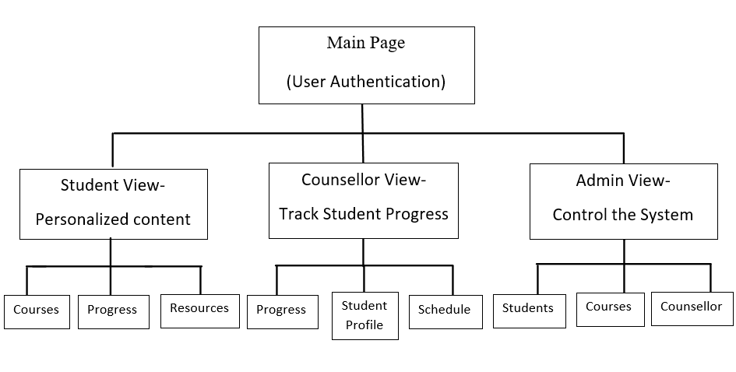

Main Page

(User Authentication)

Student View-

Personalized content

Admin View-

Control the System

Counsellor View-

Track Student Progress



Student Profile

Schedule

Progress

Counsellors

Courses

Students

Resources

Courses

Progress



This diagram represents the flow of the four main modules:

1. Main Page (User Authentication): Handles login and determines the role of the user.
2. Student View: Displays learning content based on the learner's type.
3. Counsellor View: Allows to track student progress and assist them if needed.
4. Admin View: Enables system management, user roles, and content organization.

***Design of the System***

The Adaptive Mentor system is designed using the MVC (Model-View-Controller) architecture, ensuring modularity, scalability, and maintainability.

Key Design Aspects:

1. **User-Friendly Interface:**
   * Separate views for students, counsellors, and admins.
   * Intuitive navigation for course tracking, progress monitoring, and resource access.
2. **Database-Driven Content Management:**
   * Stores user data, course progress, grades, and resources dynamically.
3. **Secure Authentication (Django):**
   * Role-based access control (students, counsellors, admins).
   * User authentication using Django’s built-in security features.

***Report of the System***

The Adaptive Mentor system will be developed through a structured four-phase approach, ensuring a robust and efficient learning platform.

The steps to create this project include:

1. During registration, students will answer questions about their learning preferences (e.g., visual, auditory, or kinetic) in a form.
2. Based on their preferences, the system will give them customized study material like videos, articles, or exercises.
3. Feedback and usage data will be analyzed to keep improving the system.
4. The frontend will be developed using HTML, CSS, and JavaScript.
5. The backend will be built using Python, Django, and MySQL to manage data and users.

Project Development Phases:

1. **Phase 1: Requirement Gathering & System Design**
   * Identified user roles (students, counsellors, admins).
   * Designed the MVC architecture for modularity and scalability.
2. **Phase 2: Frontend & Backend Development**
   * Frontend: Developed using HTML, CSS, JavaScript for an intuitive user experience.
   * Backend: Implemented with Django for authentication and data management.
3. **Phase 3: Integration & Testing**
   * Integrated frontend with backend for seamless data flow.
   * Conducted unit testing and user testing to ensure functionality.
4. **Phase 4: Deployment & Evaluation**
   * Deployed on a secure server for accessibility.
   * Evaluated performance and user feedback for improvements.

As of now, we have completely finished Phase 1. In Phase 2, the frontend has been developed, and backend development is in progress.

***Objectives***

* **Personalized Learning:** The tool matches educational content to each student’s learning style, making lessons more useful and interesting.
* **Dynamic Adjustments:** The system changes the difficulty and format of lessons based on the student’s preferences and progress.
* **Learning Style Analysis**: It learns from user input to understand behaviour and improve the experience.
* **Better Engagement:** By giving content that suits their style and speed, students stay more focused and motivated.
* **Progress Tracking:** The tool keeps track of the student’s growth over time, making it easy to see improvements and areas that need more attention.

***Operating Environment***

1. **Hardware Requirements:**

* Minimum 4GB RAM, Intel i3 processor, 100GB storage.
* Internet connection for cloud-based access

1. **Software Requirements:**

* OS: Windows / Linux / macOS
* Frontend: HTML, CSS, JavaScript
* Backend: Python, Django
* Database: MySQL
* Version Control: Git/GitHub

***Brief Description of Technology Used***

Frontend Technologies:

* HTML5 – For structuring web pages
* CSS3 – For styling and responsive design
* JavaScript (ES6+) – For interactive features

Backend Technologies:

* Python 3.10+ – Core programming language
* Django 4.2+ – Web framework for secure authentication and MVC architecture

Database:

* MySQL 8.0+ – Relational database management system

Version Control:

* Git 2.40+ – For tracking code changes
* GitHub – For repository management and collaboration

Development Tools:

* VS Code (Latest Version) – Code editor

***Advantages and Limitations***

**Advantages:**

* Personalized learning enhances student engagement.
* Role-based access ensures security and efficiency.
* Scalable and adaptable for future improvements.
* Real-time progress tracking for students and counsellors.

**Limitations:**

* Requires a stable internet connection.
* Initial setup demands time and technical expertise.
* Performance may vary based on server load.
* Dependency on database management for smooth operation.

***Benefits of the project for the society***

This project makes education more effective by personalizing it for each student. It helps them learn and remember information better. By improving education, it supports individual growth and creates a more skilled and knowledgeable society, which benefits everyone.